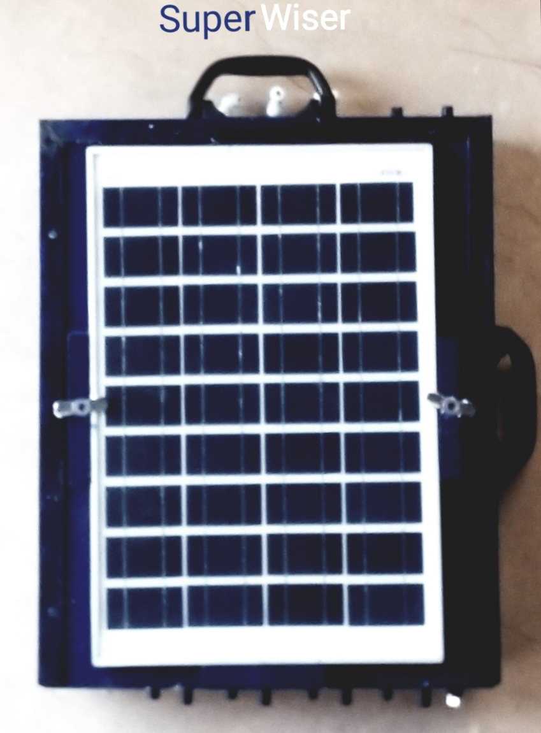

**Rough working**

• It serves 6 following functions

1. Agriculture Spray

2. Anti-Mosquito

3. Irrigation

4. Misting

5. Soft Washer

6. Musical Fountain

• It is operated by a dedicated app.

• There are preferably 8 output 12v solenoid valves that are controlled by relays that are controlled by a dedicated microcontroller.

• Any number of valves can be dedicated through app for any function.

• One valve may serve multiple functions.

• On "Quick Start”, or "Set the Schedule" button being pressed, only output valve options are shown which were previously dedicated for that purpose.

• Then, one or multiple output valve, time periodicity and pump speed is selected.

• Upon pressing the "Set the Pattern” button on the app, that is clock-wise, anti-clockwise or running, valves turn on and off like decorative lights giving a very pleasant view for misting, irrigation and musical fountain.

• Liquid used since the start and flow rate are calculated by flow sensor in the machine and hence, displayed on the app.

• On “Musical Fountain” function being selected on the app, and "start the Music" button being pressed, the audio equalizer gets turned on the app, and the amplitude of the sound in surroundings is continuously sent to the machine, which sets speed of the pump according to the current amplitude, giving a feel of singing /musical fountain.

• Signals can be sent from app to the machine and vice-versa through protocols like MQTT etc.

• Current weather is uploaded on the app through internet via weather API.

• Direction is dedicated to each valve preferably out of 8 directions, then whenever the user presses "Smart Wind Directional "button, only those valve or valves switch on that are dedicated to the same wind direction as the current wind direction. where "current wind direction" is the direction of wind at that time retrieved from internet by the machine itself and "Valves dedicated to that direction" means valves dedicated to certain direction in the app.

**Problems that are solved by this machine**

1. Each and every species of plants requires a different amount of water and supplements and that too through different modes like roses prefer very fine mist as heavy jet spray can damage their flowers whereas plants like aloe-vera can be watered by sprinklers.

2. Moreover, the kind and quantity of supplements needed also vary from plant to plant. for Instance, fertilizer for rose and palm are different.

3. To have healthiest plants possible, instead of filling the pots to the rim at once, much more effective way to irrigate them would be to water them after every 15 minutes with just 10 mI of water (let's say) as it would reduce the chances of waterlogging, maintain the temperature of plant and soil, but it is humanly highly inconvenient.

4. Organic farming is being encouraged, as vegetables available in the market lack nutrition and are toxic. So, it is advised to have one's own terrace kitchen garden, but the problem is that vegetables require intensive farming and nobody has the time or desire to step up the stairs to water them after regular intervals.

5. Even if someone can manage to water their terrace garden, it is not advisable to spray fertilizers in human presence as they can be very toxic to humans.

6. Same goes for anti pest sprays.

7. Everyone needs a soft washer for cleaning almost anything like cars, windowpanes, floor etc.

8. Solar energy is being encouraged as it is eco-friendly and free.

9. When sitting in outdoors, who would mind a mild mist and a singing fountain at the same time.

10. Misting can lower temperature up to 30° C and lighten up the mood, and singing with a musical fountain is everyone's desire.

11. Water needs to be saved, so only required amount of water and fertilizer need to be sprayed with calculated volume in litres or millilitres So that, wastage can be minimised.

**Single line diagram**

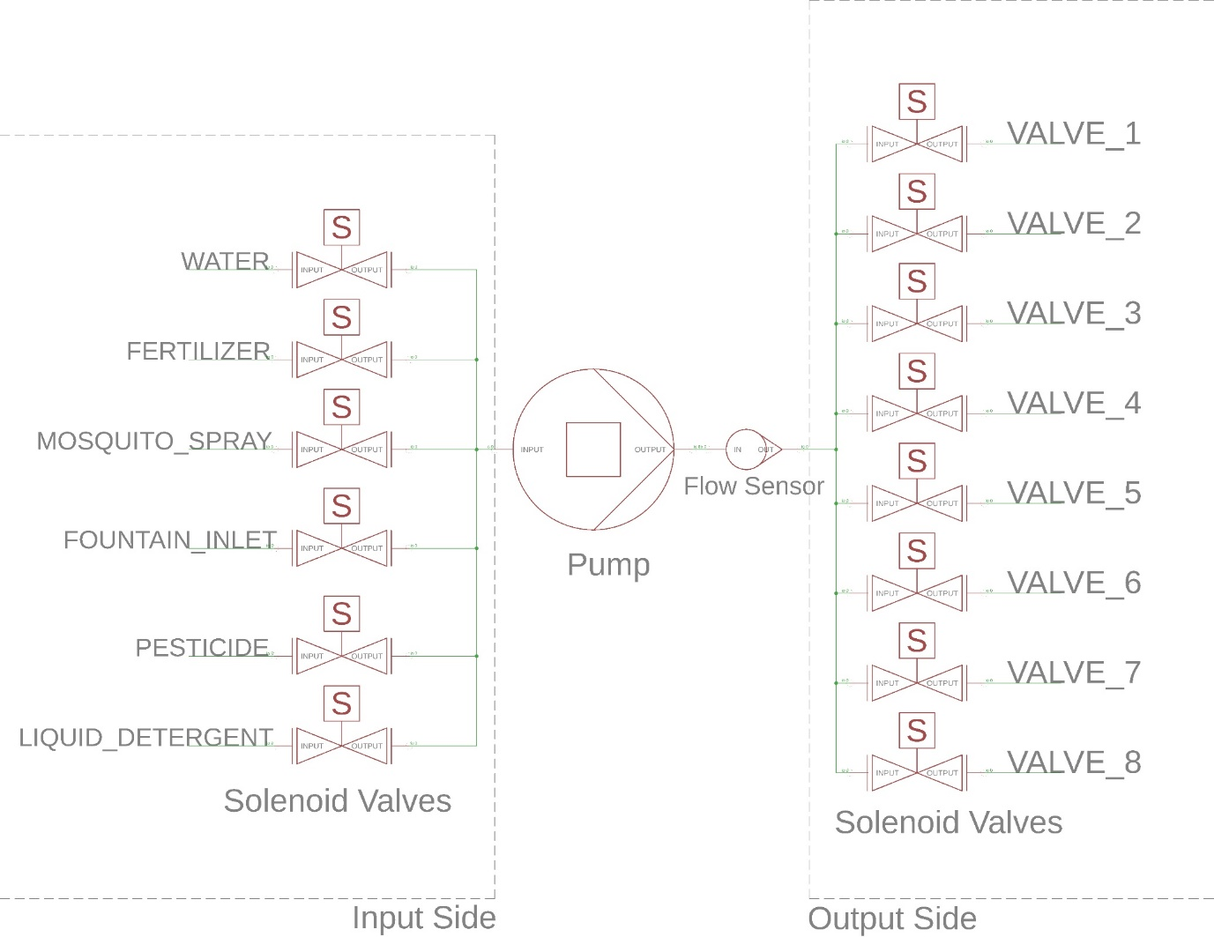

• At the input side, according to the function selected through the app, the specific solenoid valve switches on. For example, if “MISTING” function is selected, the valve belonging to water switches on, and if “ANTI-MOSQUITO” function is selected, then valve belong to mosquito-spray switches on and so on.

• At the output Side, the selected output valves switch on.

• Pump is switched on at the speed set through the app.

• Flow sensor continuously reports to the app about the volume of liquid that passed through it and the flow rate at the moment.

• When liquids like fertilizer, mosquito spray, pesticide or liquid detergent are selected, their corresponding solenoid valve switches on for a small duration and then solenoid valve corresponding to water switches on for much larger duration to dilute the solution, and hence, the resulting solution is sprayed by the machine. The concentration of the resulting solution can be controlled through the app.

**Closed machine labelling**

• Power adapter of 15V, 2.5 A is for Power backup in case Sunlight is poor or machine has to be used for longer duration.

• 20 W Solar plate charges the 12V Lead acid batteries with the help of Solar charger fitted inside the machine.

• Input water is supplied through a tap that is always kept on.

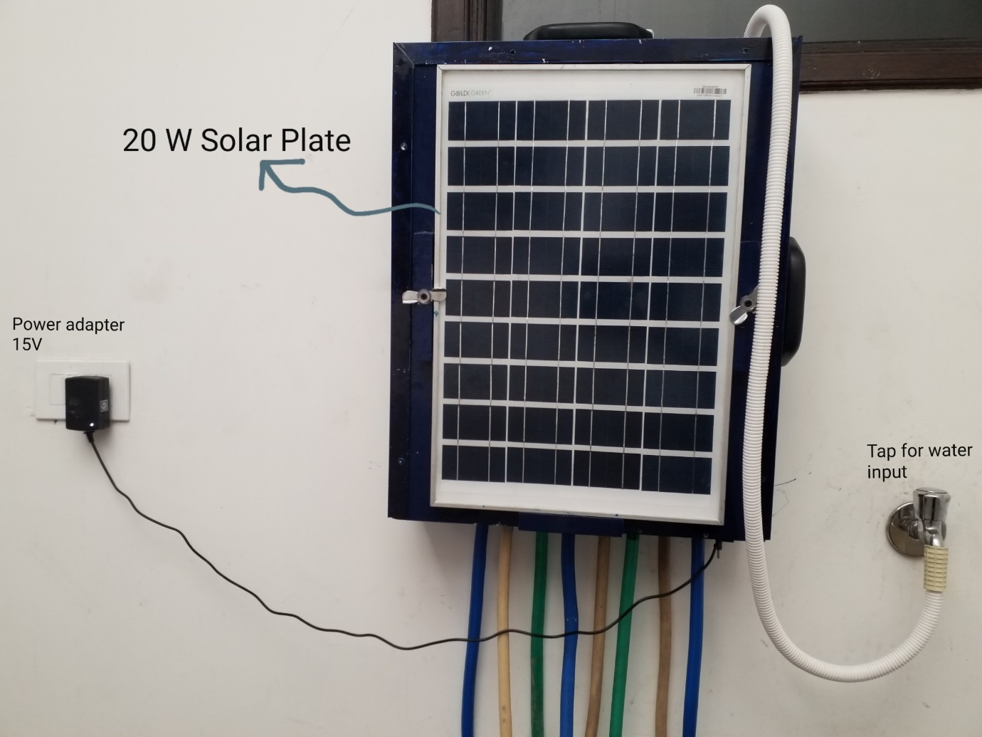

**Input Side**

• At the input side, as shown in the top View, the nozzles are for Various functions as labelled below. fertilizer, anti-mosquito and liquid detergent bottles are connected to the white nozzles.

• Each nozzle is connected to its corresponding solenoid valve.

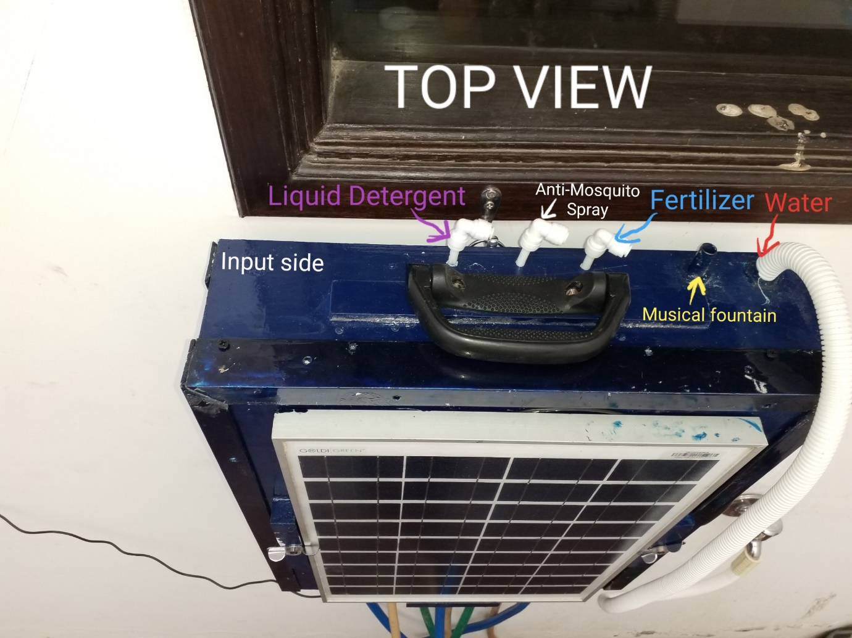

**Output Side**

• At the output side, as shown in the bottom View, the 8 output 1/2" output nozzles are connected to 1/2" pipe where each pipe is dedicated to single or multiple functions like misting, irrigation, fertilizer etc.

• There is a ON/OFF button to switch on/off the machine on the bottom so that it is prevented from rain.

• And there is a power back-up Socket where pin of power adapter goes in.

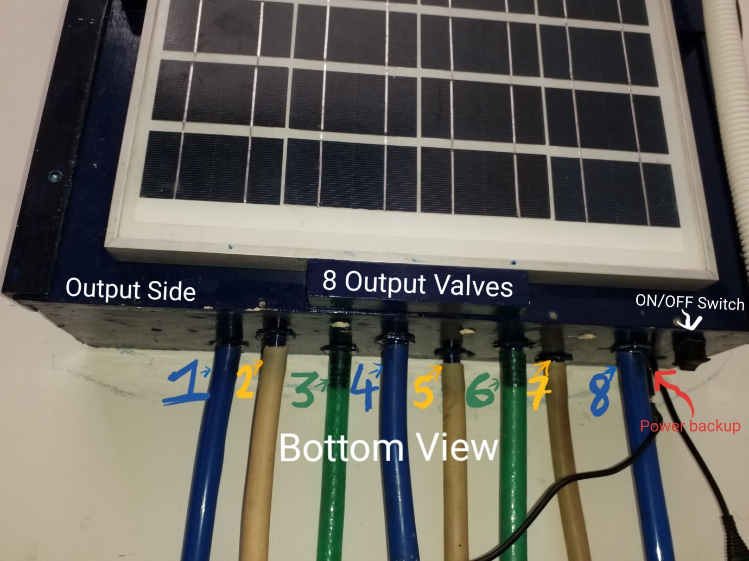

**Opened machine labelling**

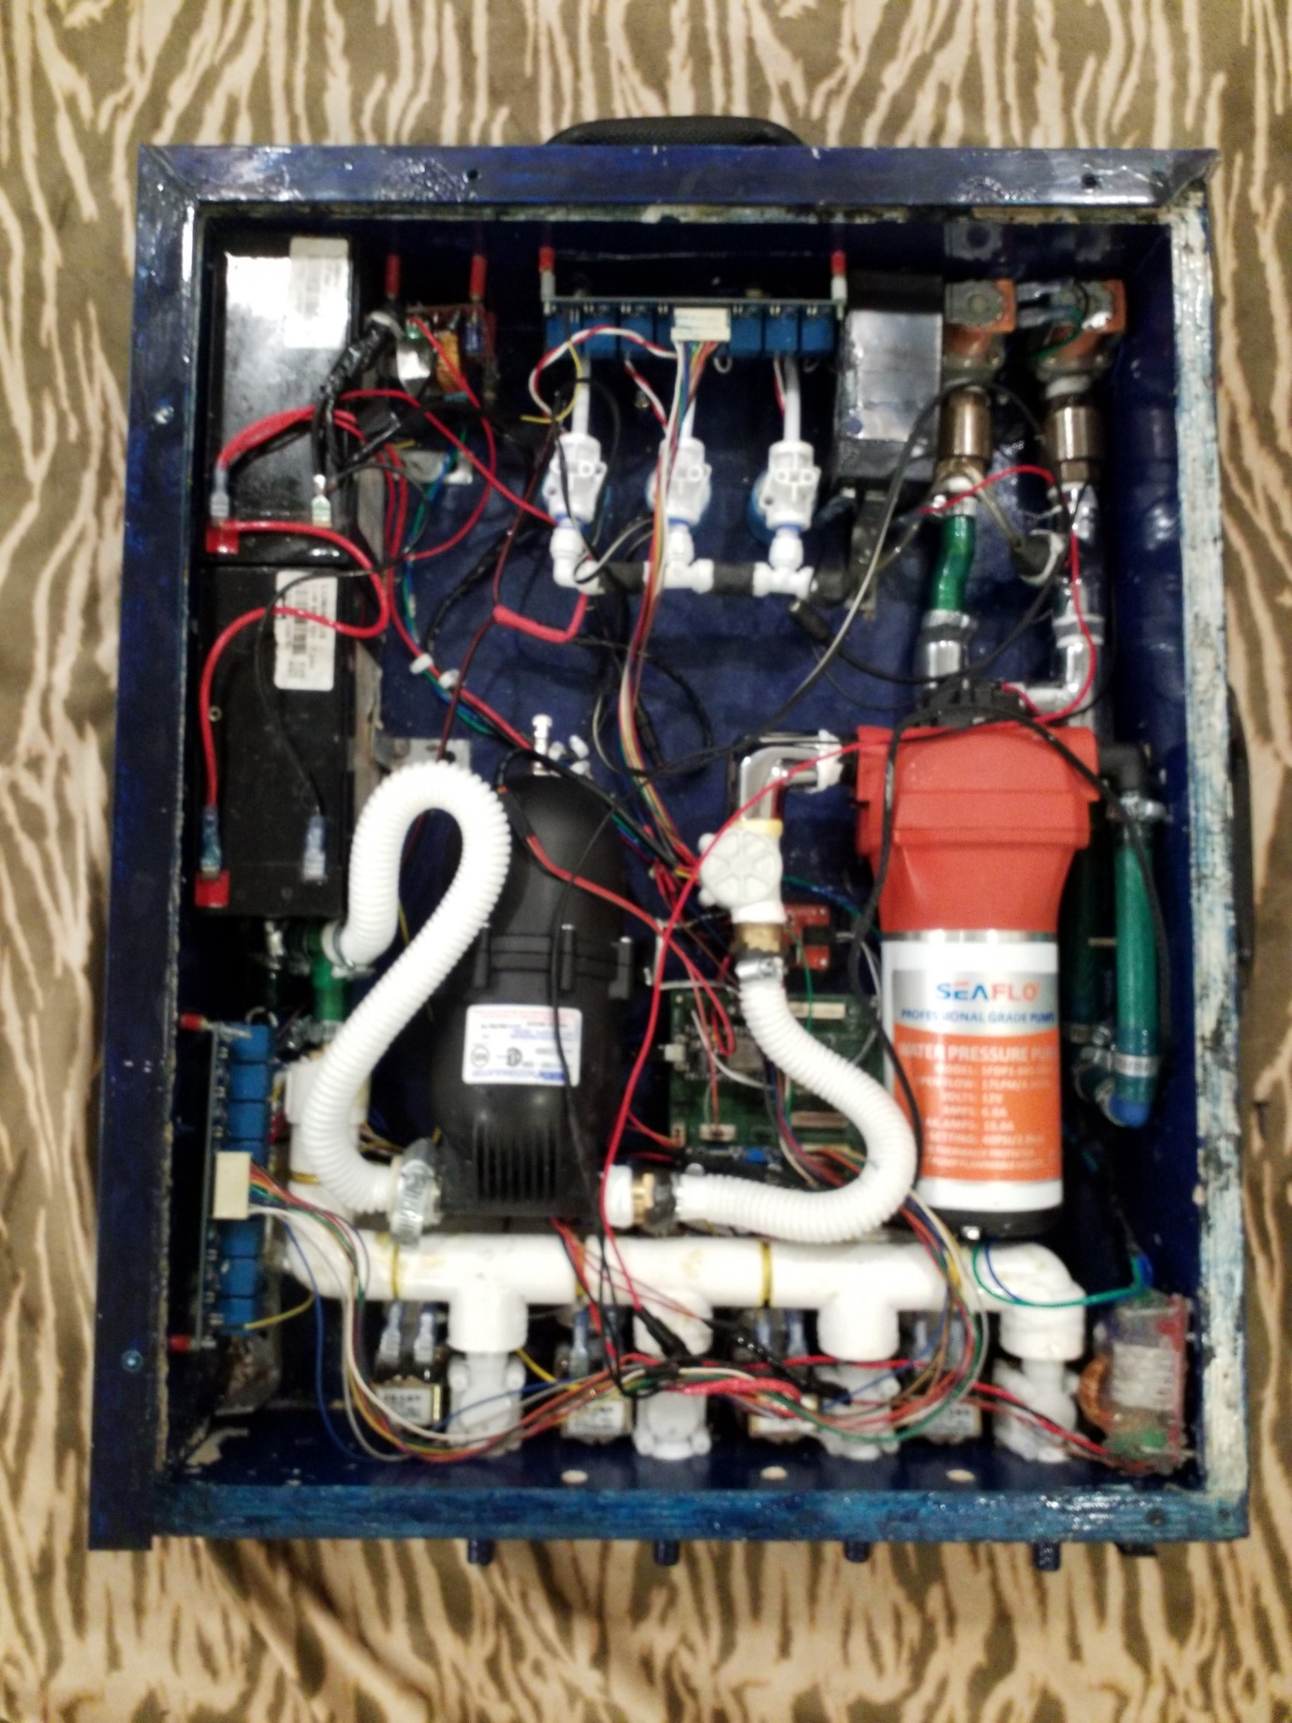

**Details about Parts**

1. **Pump**-Features & benefits: positive displacement pump, can run dry, quiet operation, demand pump, easy connect fittings, industry standard mount pattern, built-in thermal protection, typical applications: agricultural spraying, general industrial, automotive, marine/rv, type: 5 chamber positive displacement diaphragm pump, self-priming, capable of being run dry mode: demand liquid temperature: 140°f (60°c) max. Priming capabilities: 6 feet (1. 8 m) suction lift max pressure: 60 psi (4. 1 bar) inlet/outlet ports: 1/2″-14 mnpt weight: 7 lbs (3. 17 kg) duty cycle: continuous leads: 16 awg, 4. 5″ long with/leads, 2-pin connector voltage: 12v

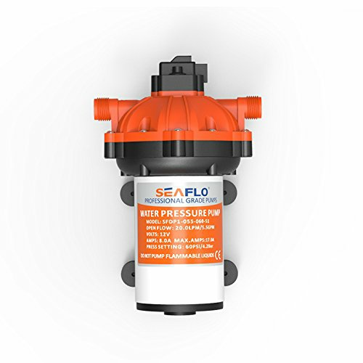

**Solenoid valve** -12V DC 1/2″ Electric Solenoid Water Air Valve Switch (Normally Closed) Controls the flow of fluid+air and act as a valve between high-pressure water or any fluid! This liquid valve would make a great addition to your robotic gardening project. There are two ½” (Nominal NPT) outlets. Normally, the valve is closed. When 12Vdc is applied to the two terminals, the valve opens and water can push through.

1. The valve works with solenoid coil which operates electronically with DC 12-volt supply. As it is normally closed assembly, it opens the flow of liquid as soon as power ON and stops/blocks the flow when the supply voltage removed.

1. Suitable for liquid, water, oil, high-end water heaters, intelligent drinking fountains, water heaters, straight drinking machines, water purification machines, steam machines, Energy-saving air-conditioning, water treatment, cooling equipment and water industry and other fields, the use of a large number

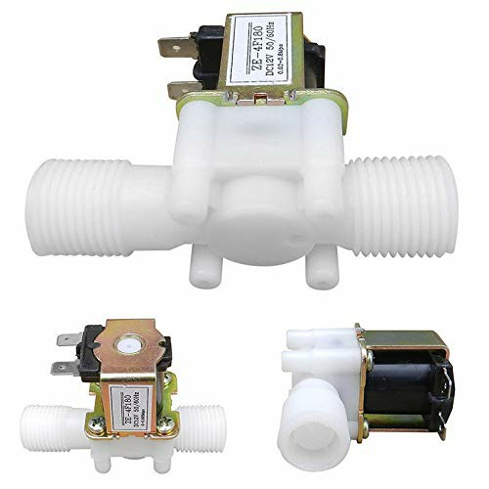

2. **flowmeter Sensor**-This sensor sits in line with your water line and contains a pinwheel sensor to measure how much liquid has moved through it. There's an integrated magnetic hall effect sensor that outputs an electrical pulse with every revolution. The hall effect sensor is sealed from the water pipe and allows the sensor to stay safe and dry. The sensor comes with three wires: red (5-24VDC power), black (ground) and yellow (Hall effect pulse output). By counting the pulses from the output of the sensor, you can easily calculate water flow. Each pulse is approximately 2.25 millilitres. Note this isn't a precision sensor, and the pulse rate does vary a bit depending on the flow rate, fluid pressure and sensor orientation. It will need careful calibration if better than 10% precision is required. However, its great for basic measurement tasks! We have as example Arduino sketch that can be used to quickly test the sensor, it will calculate the approximate flow of water in liters/hour. The pulse signal is a simple square wave so it’s quite easy to log and convert into liters per minute using the following formula. Pulse frequency (Hz) / 7.5 = flow rate in L/min. Flow Rate (Litres/hour) = (Pulse frequency x 60 min) / 7.5Q Features: • Model: YF-S201 • Sensor Type: Hall effect • Working Voltage: 5 to 18V DC (min tested working voltage 4.5V) • Max current draw: 15mA @ 5V • Output Type: 5V TTL • Working Flow Rate: 1 to 30 Liters/Minute • Working Temperature range: -25 to +80℃ • Working Humidity Range: 35%-80% RH • Accuracy: ±10% • Maximum water pressure: 2.0 MPa • Output duty cycle: 50% +-10% • Output rise time: 0.04us • Output fall time: 0.18us • Flow rate pulse characteristics: Frequency (Hz) = 7.5 * Flow rate (L/min) • Pulses per Liter: 450 • Durability: minimum 300,000 cycles • Cable length: 15cm • 1/2" nominal pipe connections, 0.78" outer diameter, 1/2" of thread • Size: 2.5" x 1.4" x 1.4" Connection details: Red wire : +5V Black wire : GND Yellow wire : PWM output.

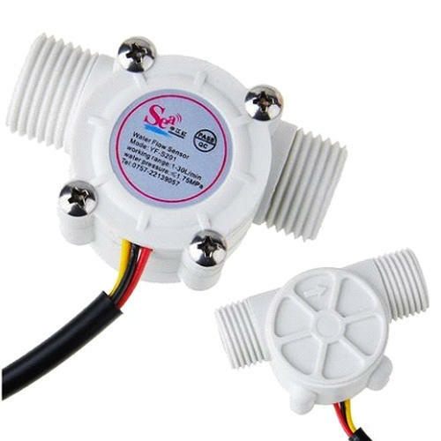

3. **Lead acid battery**-12V 7.5AH

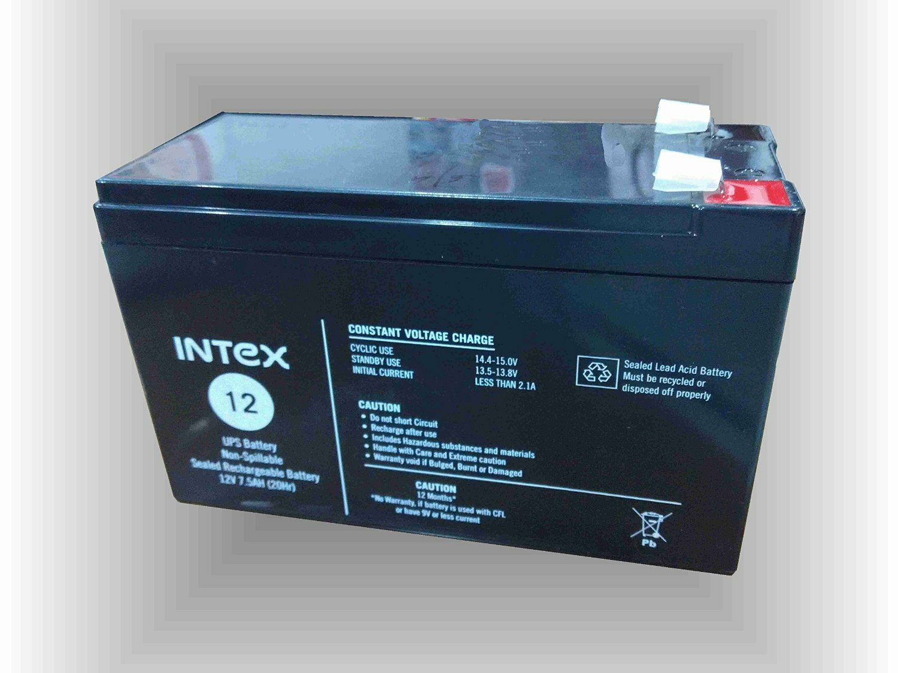

4. **Solar Charger**-Versatile charger kit for charging 6v, 12v and 24v lead acid batteries. Jumper settings for selecting the charging configuration. The product gives thermal, short circuit and reverse input circuit protection, along with led indication for input. The product can be safely used for battery charging through solar. 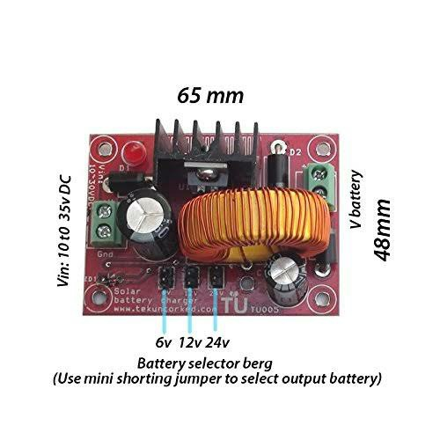

5. **Solar panel**-20W Solar Panel can be used for variety of functions. Aluminium body makes the panel Robust. It comes with five-meter-long cable which you can use to charge your devices and save on large units of electricity. Rated Power (Pmax) - 20W+- 3% Open Circuit Voltage (Voc) - 21.5V Short Circuit Current (Isc) - 1.30 A Voltage at maximum power (Vmp) - 17.7 V Current at maximum power (Imp) - 1.13 A Maximum system voltage - 600V.... Dimension of the product are 520 X 350 X 22 mm. These details along with mounting information is available in the 5th Image/ picture available for this product.

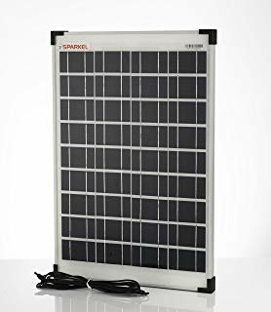

**Fittings**- Ordinary Tees and elbows

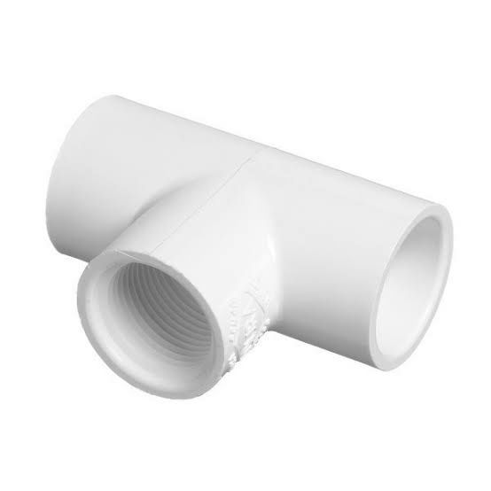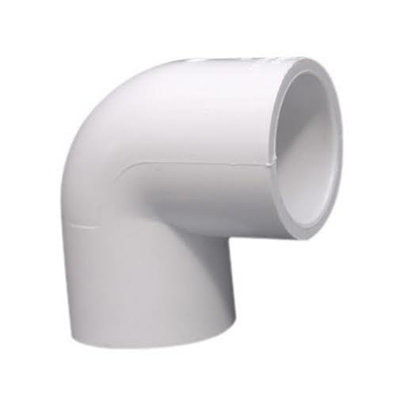

**Motherboard**- a costumed self-designed, dedicated microcontroller equipped with WIFI

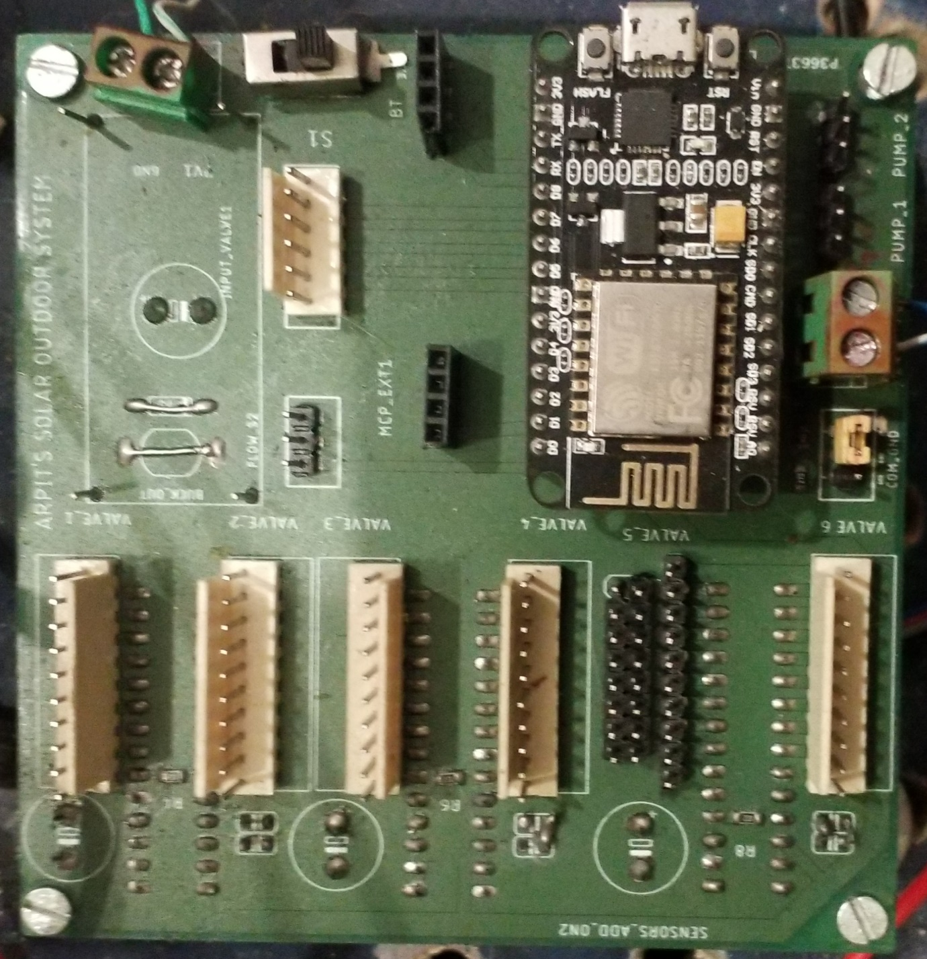

**Relay boards**-Standard interface can be directly connected with microcontrollers. Red working status indicator lights are conducive to the safe use. Widely used for all MCU control, industrial sector, PLC control, smart home control. Specifications: Working voltage: 5V, channel: 8 channel, item size: 13.4 * 5.3 * 1.7cm / 5.28 * 2.09 * 0.67in, item weight: 116g / 4.11oz, package weight: 118g / 4.17oz, package includes: H9449 1 * 8 Channel relay module.

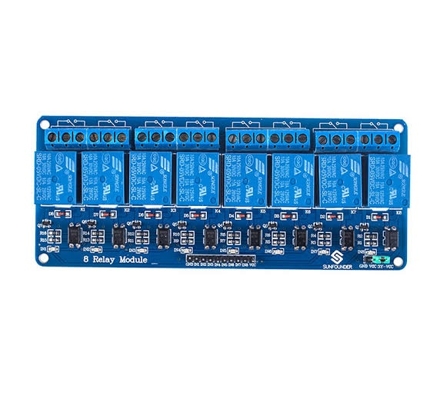

**First page working**

1. On pressing the "Settings" button, directions to each output valve can be dedicated, so that whenever "Smart Directional Switching" button is pressed, the app finds the current wind direction and if there are valve or valves dedicated to that direction, only those valves are turned on to cover maximum area to be irrigated or sprayed. for example, in the app, if "Smart Directional Switching" button is pressed, and the wind direction at that time is towards West, then "Valve I" and "Valve 6" will switch on.

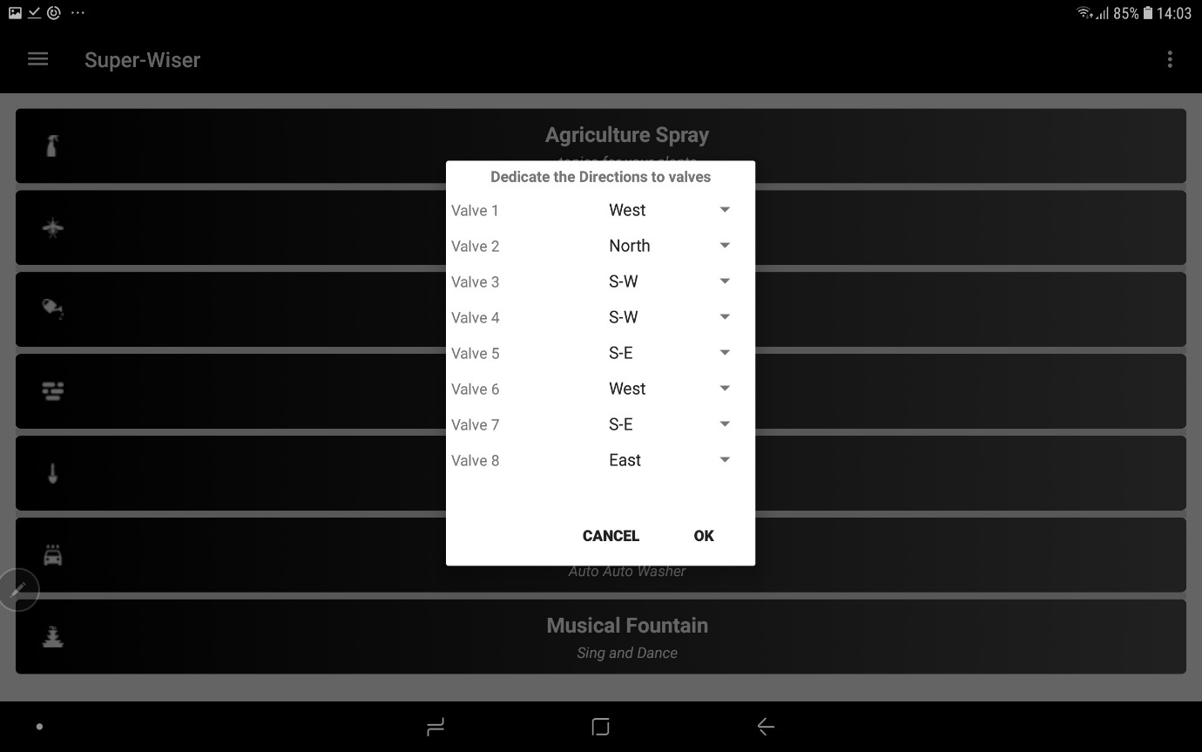

2. On pressing "Settings" button, a dialog box appears to choose the time (in minutes) after which the machine auto- switches off. for example, in this case, machine operates for 1 minute and then stops automatically.

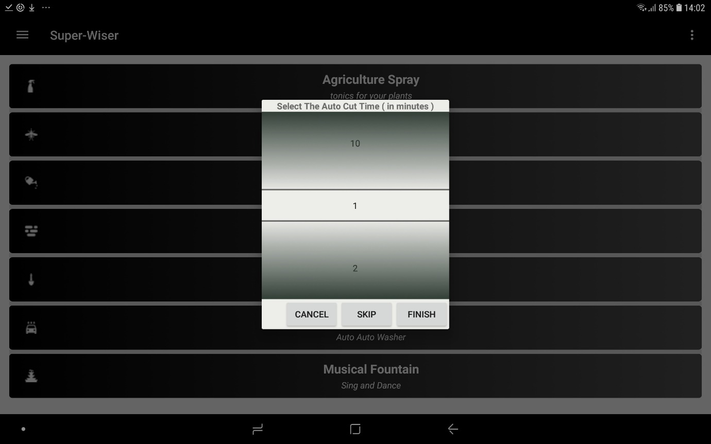

**Dedicate the valves**

1. "Dedicate the Valves" button is for dedicating valves out of total valves for the selected function. various functions can have common valves.

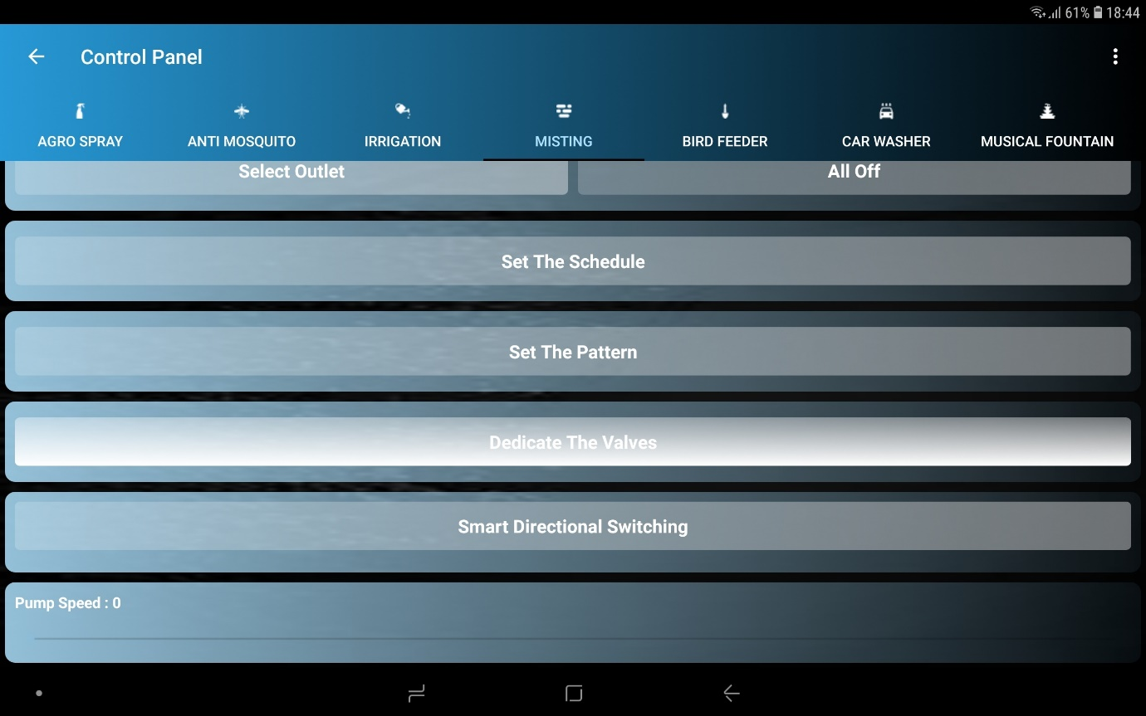

2. upon pressing the "Dedicate the Valves" button, a dialog box saying "Select the Valves for the Purpose" appears, the desired valves are selected and the "DONE!" button is pressed. This dedicates the selected valves to the function.

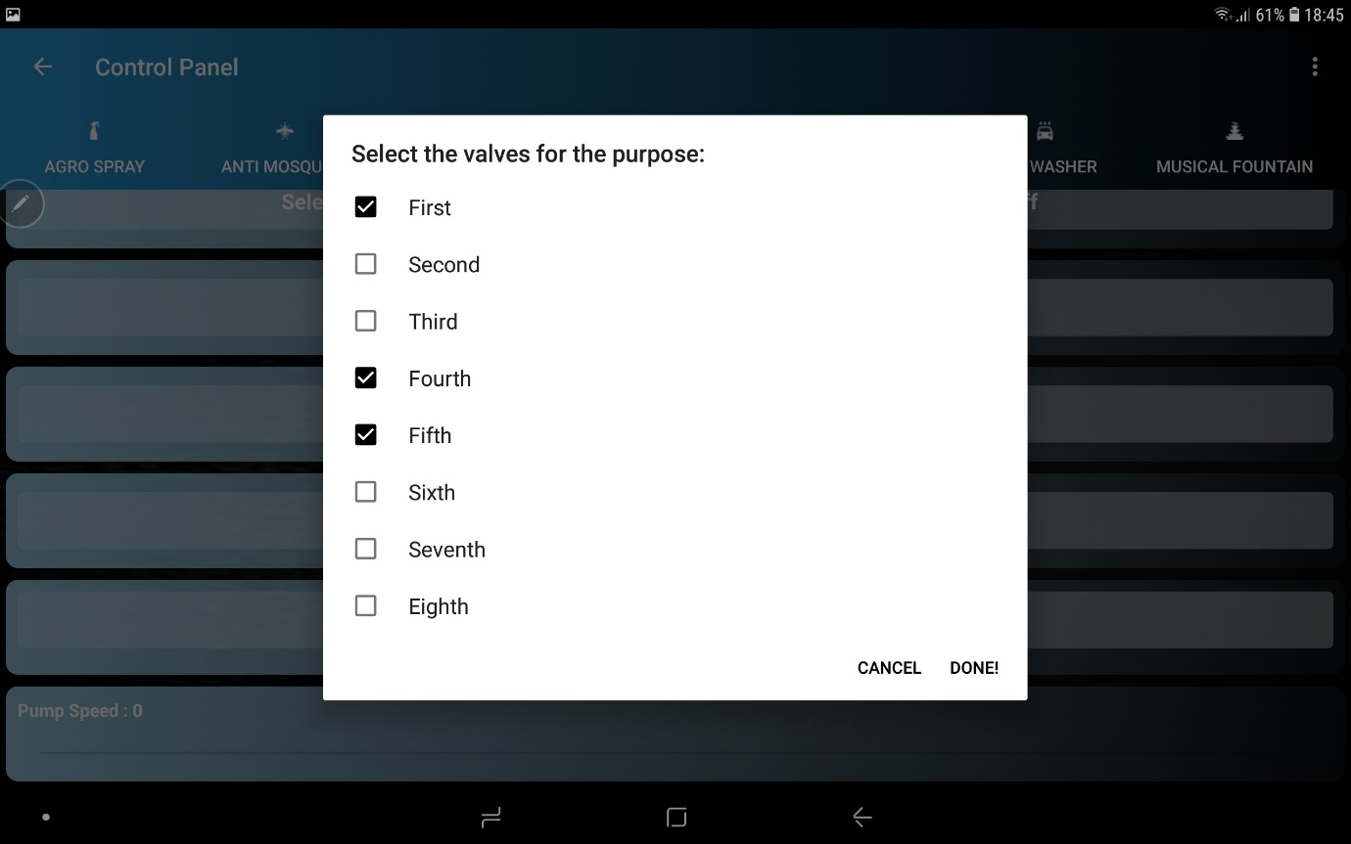

**Set outlet and All off working**

1. "Select Outlet" button is pressed, to choose output valve for the function.

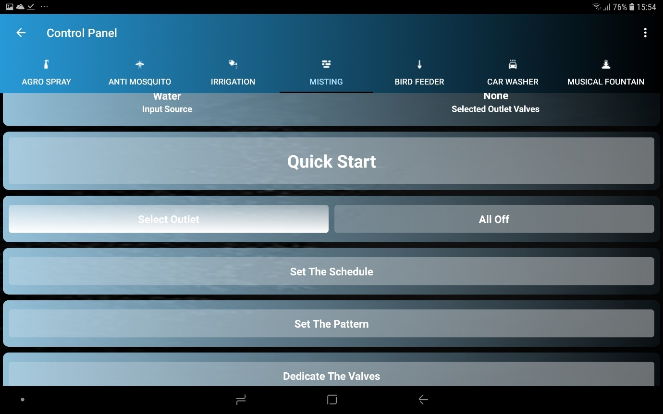

2. Then a dialog box appears from which output valve can be picked. Only those valves are shown as options which were previously dedicated to the selected function. After selecting the desired valves, “OK” button is pressed.

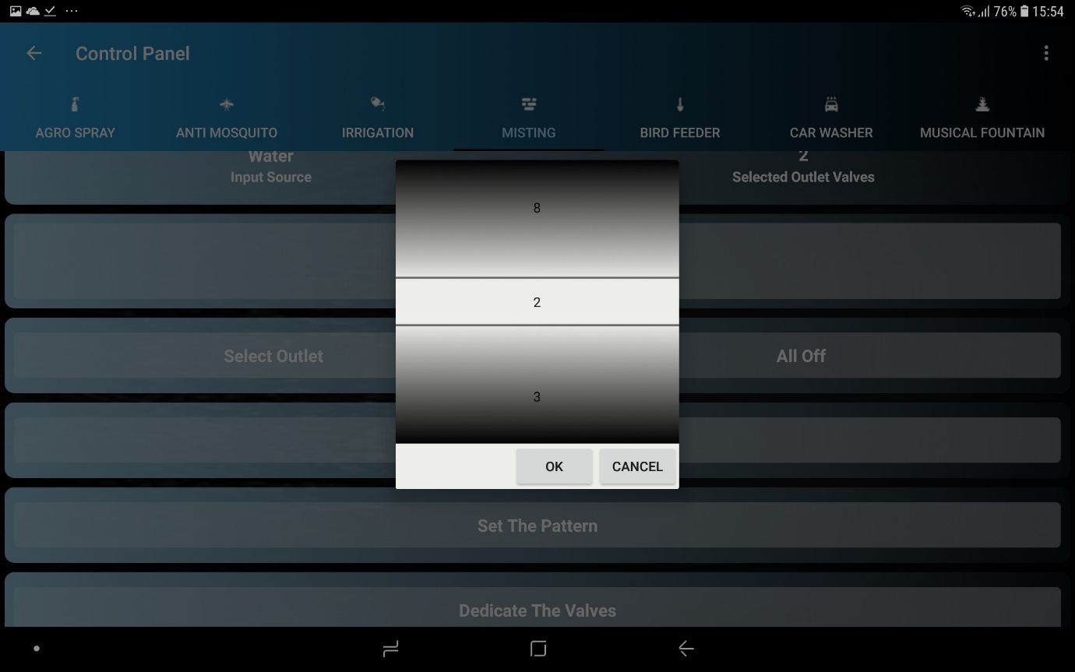

3. When "All Off" button is pressed, all ongoing operations of the machine at that time are stopped i.e. no input or output.

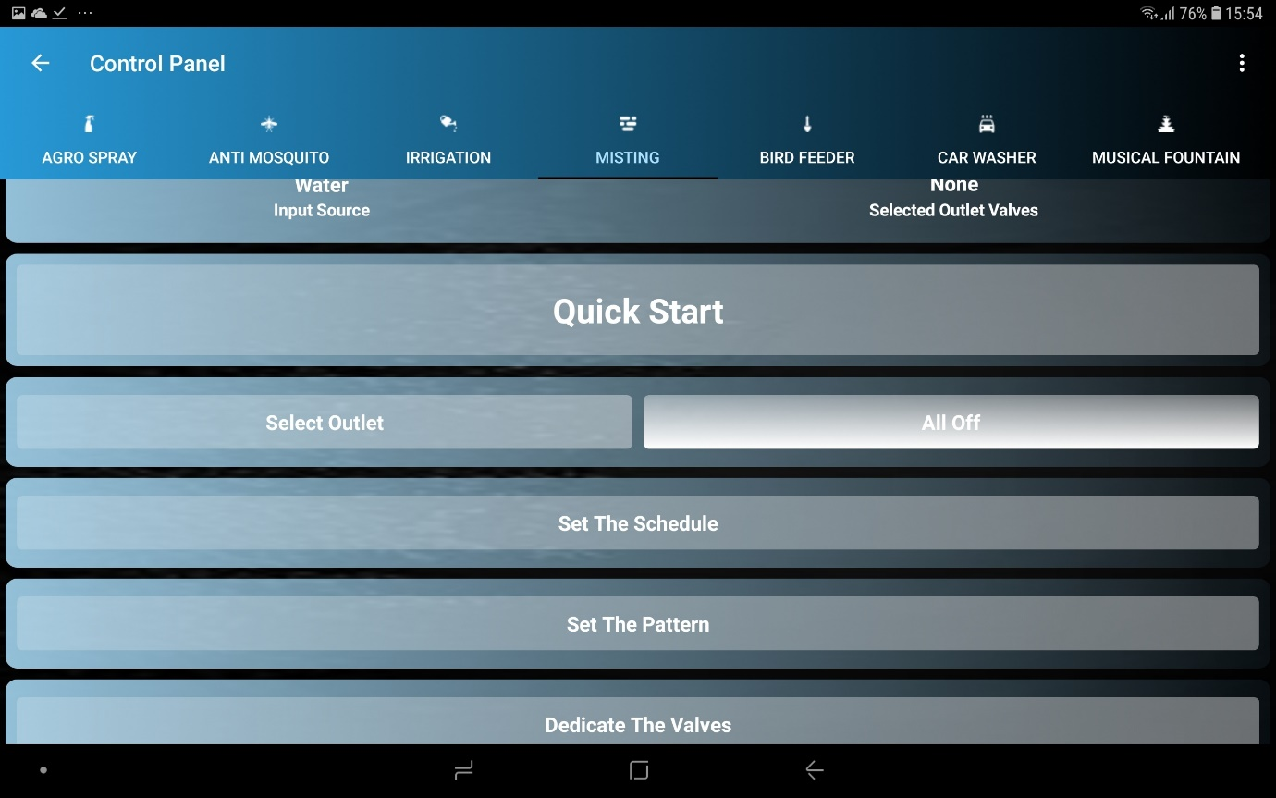

**Pump speed variation**

1. To set the speed of the pump, the speed is selected with the help of seekbar. (in this case 46 is selected speed on the scale of 0-100 (0 being the off state and 100 being the maximum speed of the pump).

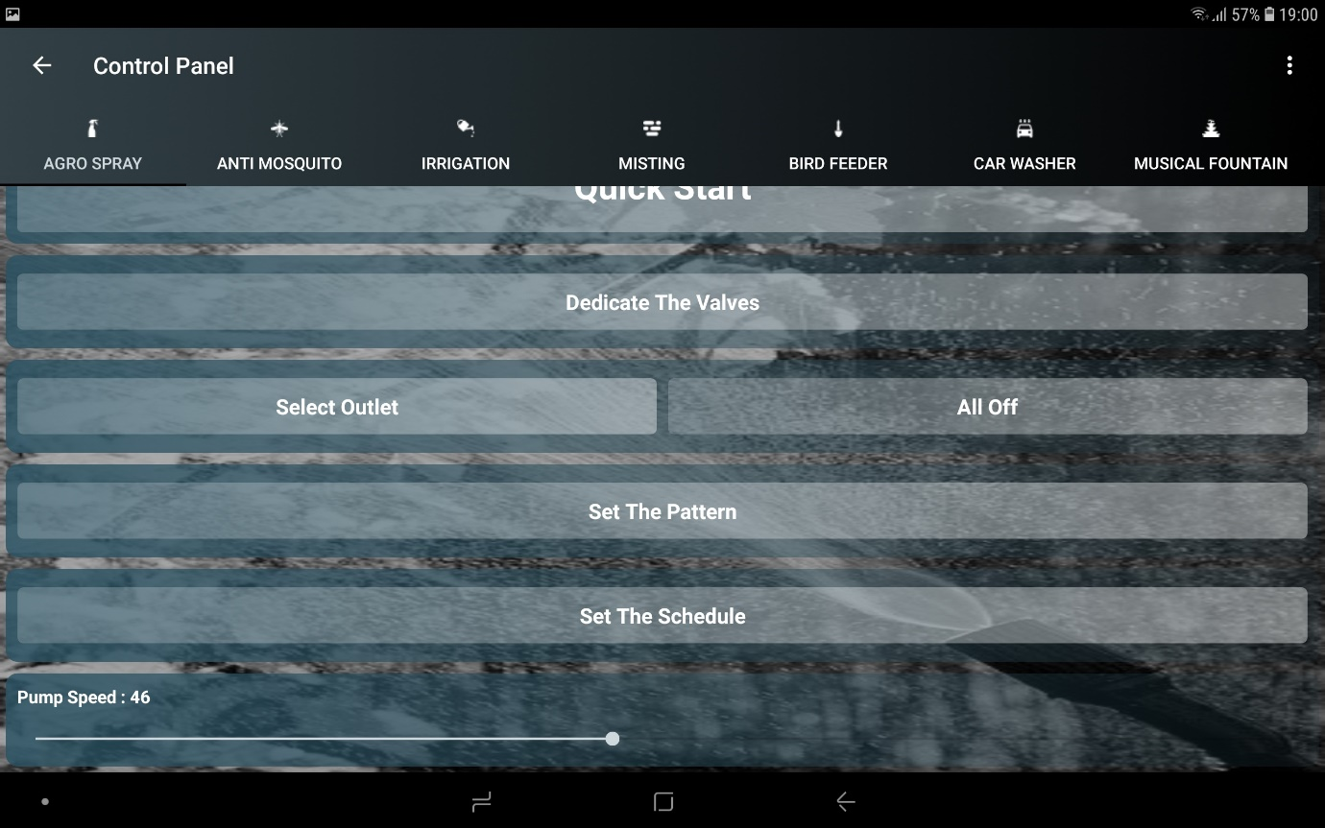

**Set the litres to be poured working**

1. "Set the Litres to be poured" button is for pouring only the selected volume of liquid to conserve the liquid.

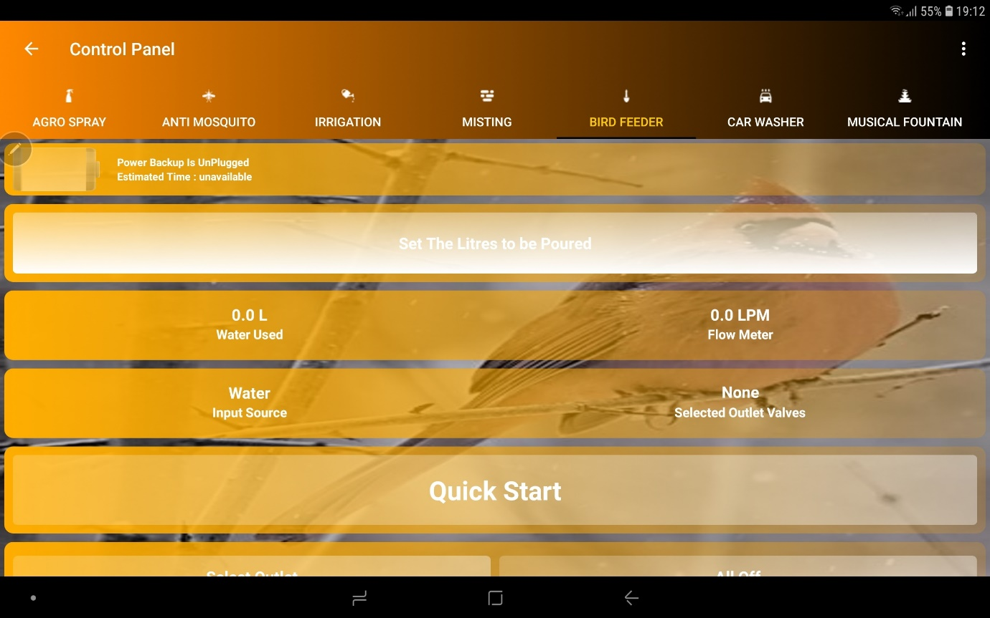

2. On pressing the button, a dialog box appears, the desired volume of liquid (in litres) is selected, and "OK" button is pressed, hence, the selected volume is poured. Like in this case, 2 litres of the liquid will be dispensed, and then the machine will stop automatically. Flow sensor takes care of it.

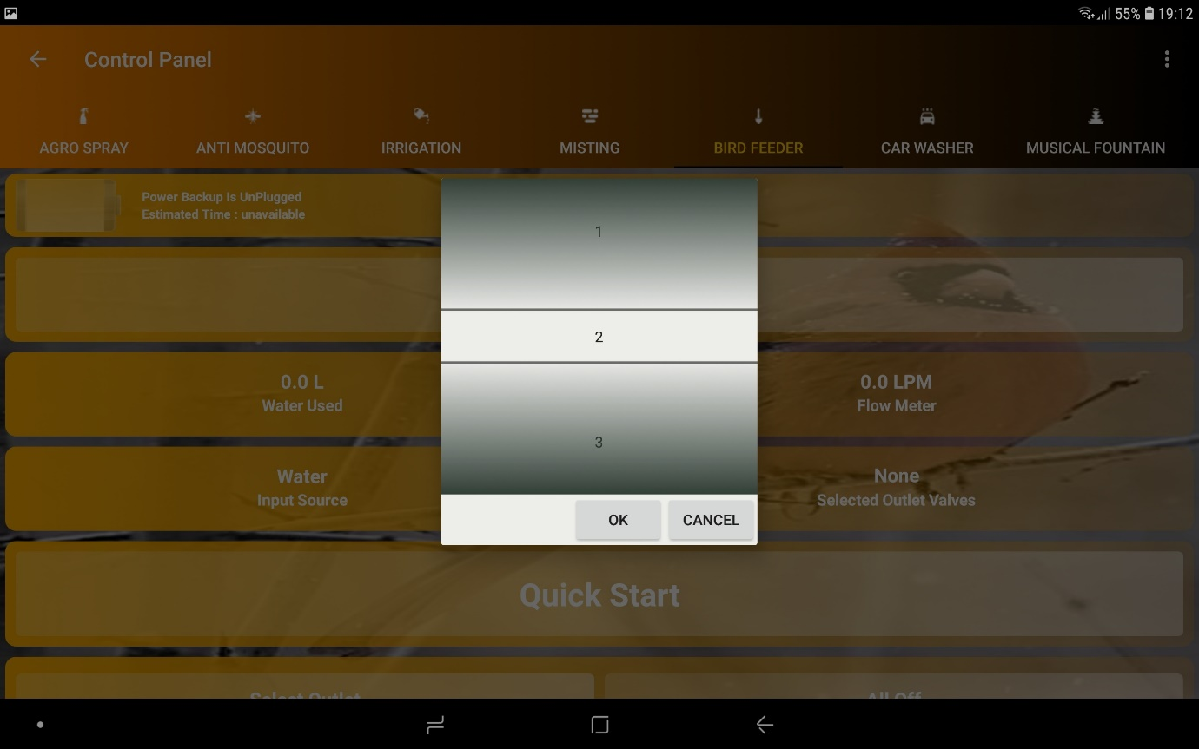

**Quick start Working**

1. "Quick Start" button is pressed for a quick launch.

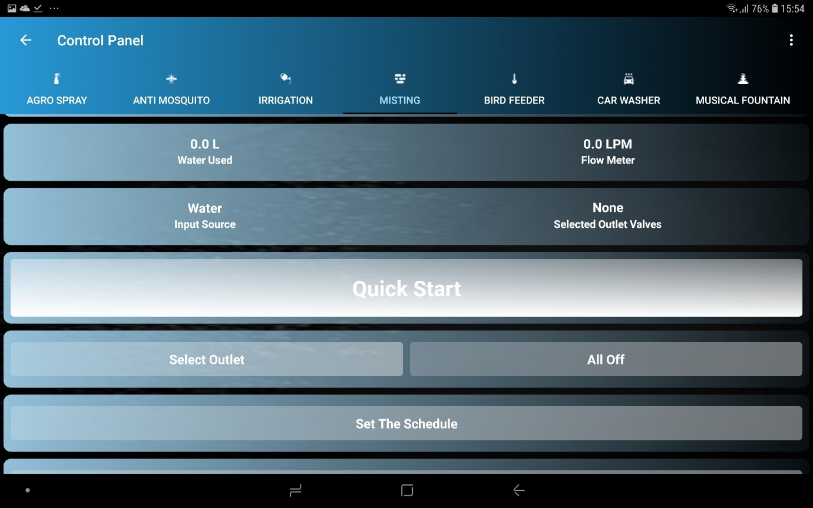

2. Then a dialog box saying, "Select valves for the Purpose" appears. (Only those valves are shown as options which were previously dedicated to the selected function), then the desired valves are selected by the user and “NEXT” button is pressed. In this case, “Valve 2" and "Valve 3" are selected for the job.

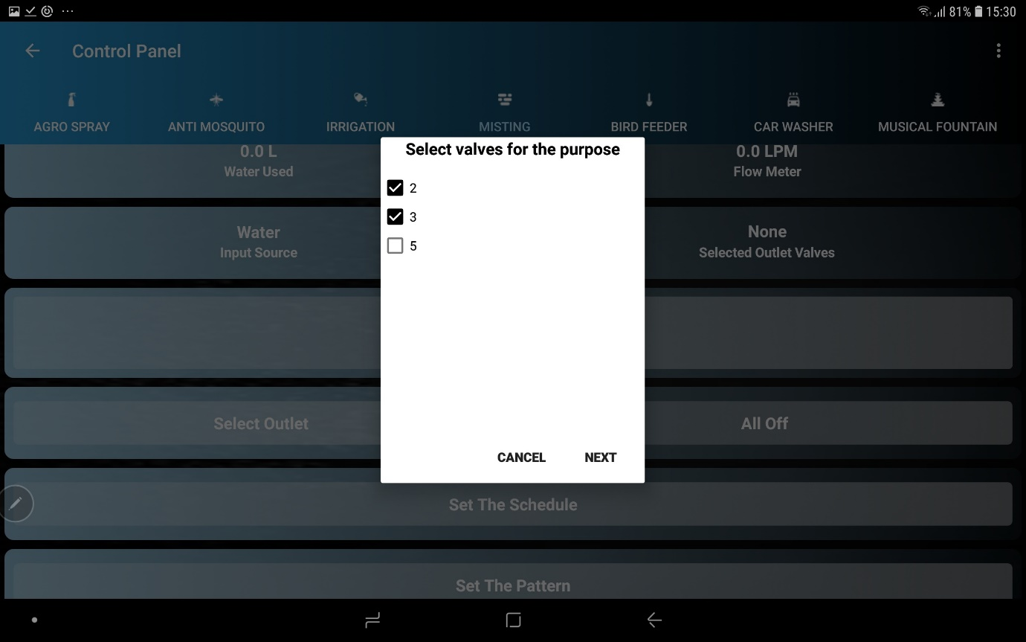

3. Then, a dialog box saying, "Set the duration (in minutes)" appears, the desired duration is selected and "NEXT" button is pressed. In this case, 4 minutes is selected as duration, meaning the machine will stay on for 4 minutes and turn off automatically after 4 minutes.

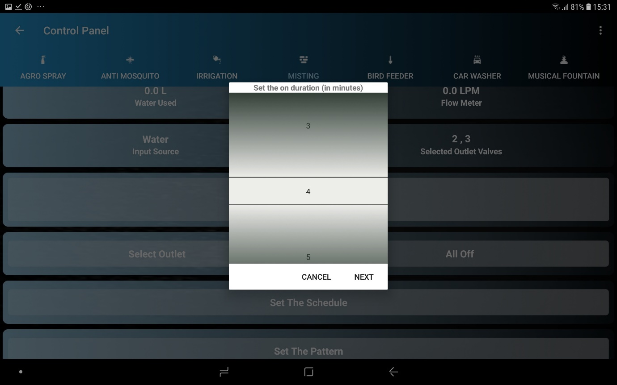

4. Then a dialog box appears to set the speed of the pump. With the help of seekbar, the desired speed is selected and "FINISH" button is pressed. (in this case 73 is selected speed on the scale of 0-100 (0 being the off state and 100 being the maximum speed of the pump).

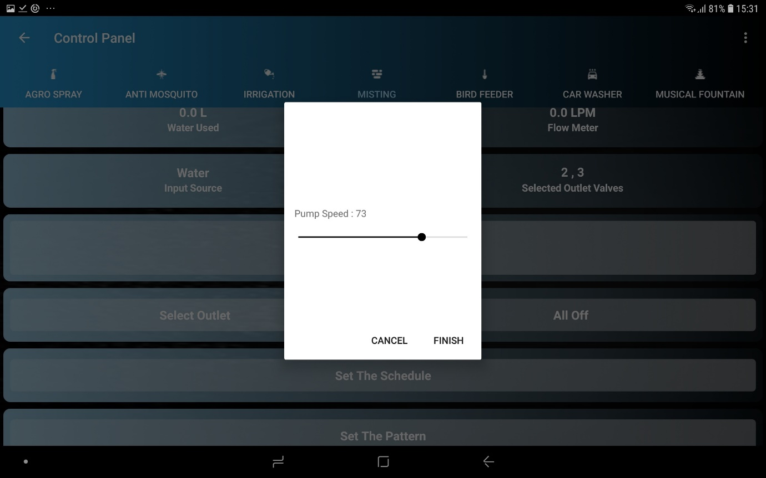

5. Then an alert dialog box appears Saying" Do you want to launch the Camera App”. if "YES" button is pressed, the camera app installed on the device that is selected through this app previously opens up.

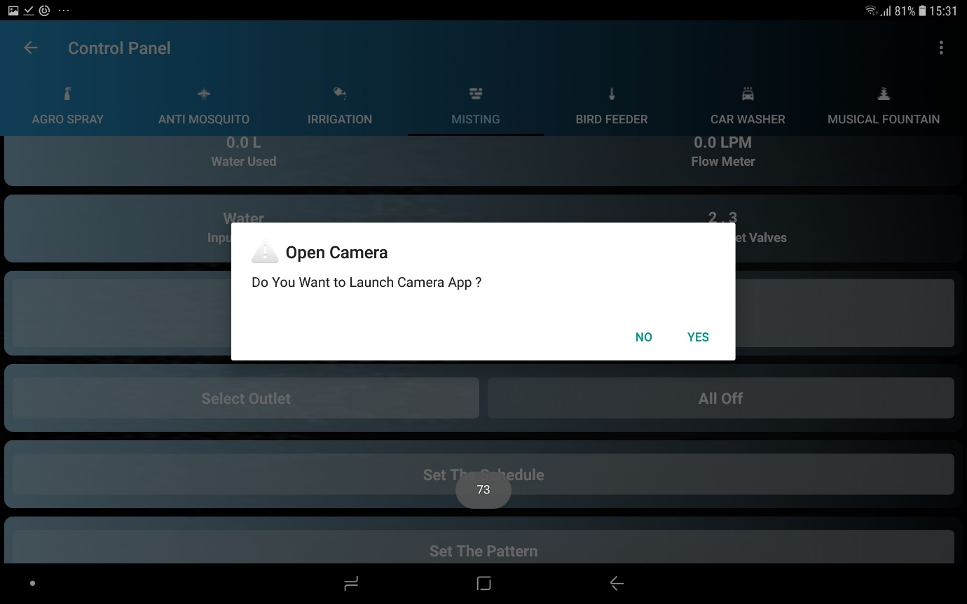

6. So that the user can see the live footage of the task for his satisfaction.

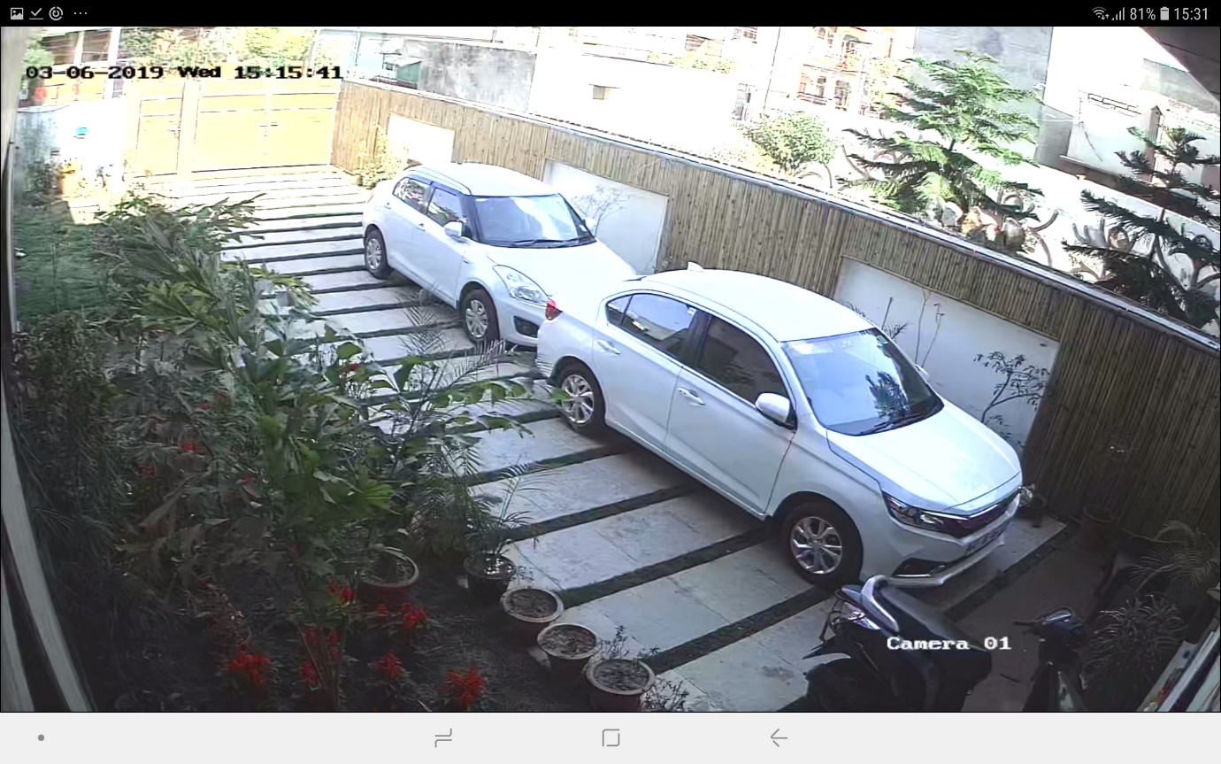

**Smart directional switching**

1. "Smart Directional Switching" button is for switching on that valve or valves that are dedicated to the same wind direction as the current wind direction. where "current wind direction" is the direction of wind at that time retrieved from internet by the machine itself and "valves dedicated to that direction" means valves dedicated to certain direction in the app, for example, in the app, I dedicate valve 2 to NW direction, “Valve 3” to South direction and so on.

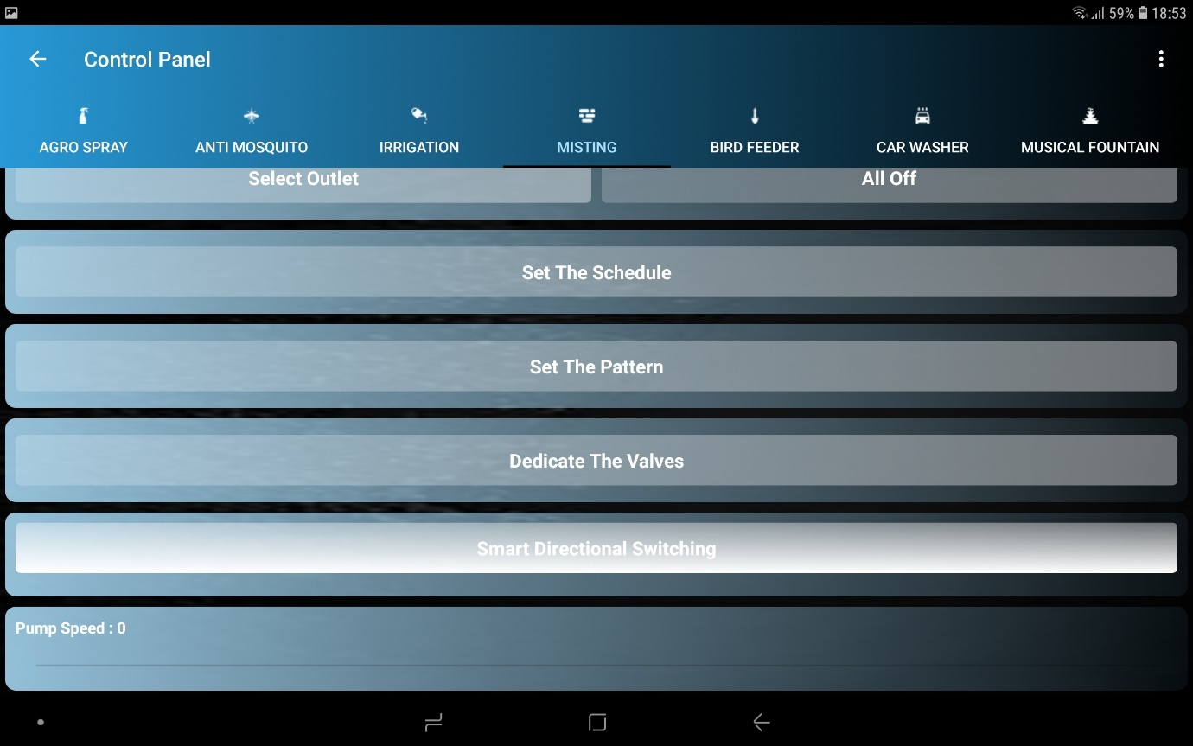

2. When the button is pressed, the valve or valves dedicated to the same direction as the current wind direction gets switched on. for example, in this case, the current wind direction is North, and “Valve 1” is dedicated to North direction, so, “Valve 1” gets switched on.

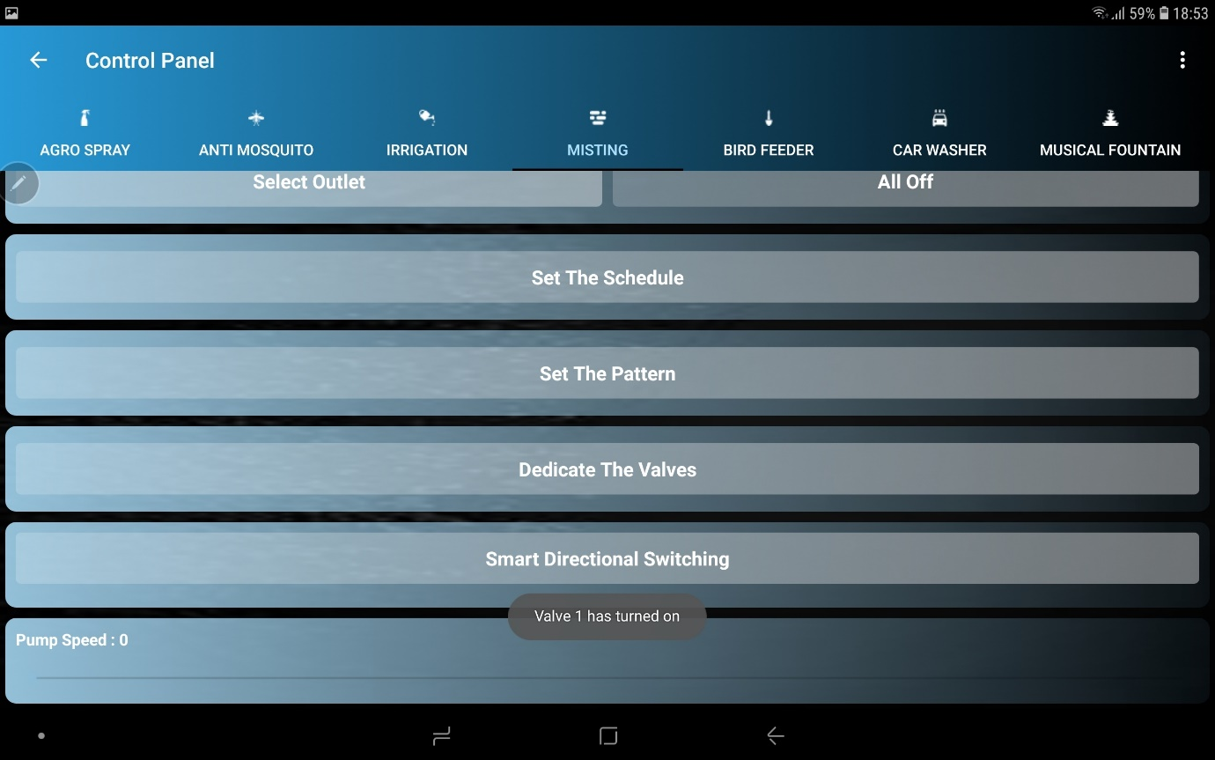

**Set the Pattern**

1. 'Patten" means the pattern in which valves turn on and off like decoration lights giving an aesthetic feel.

2. "Set the Pattern" button is pressed to perform the selected function in the way that valves switch on and off forming a pattern like decoration lights, giving an aesthetic feel.

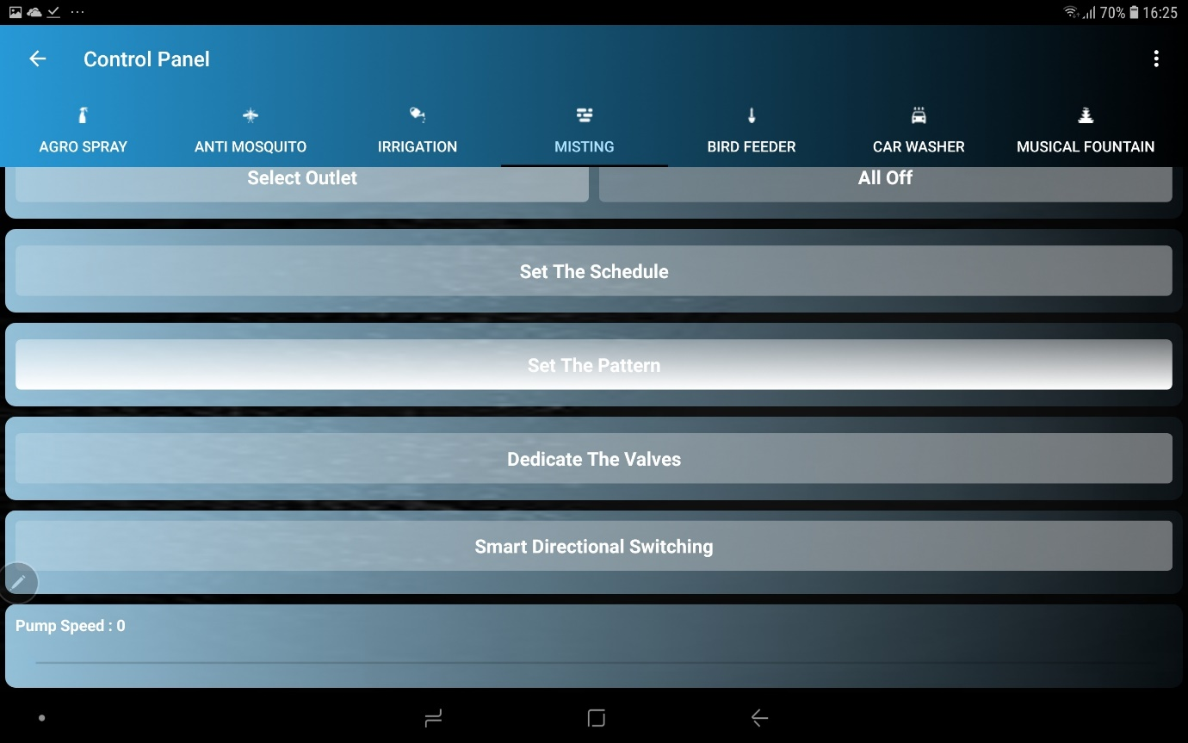

3. Then, a dialog box saying "Select The total Valves for Pattern" appears, the number of valves to perform the operation are selected and "NEXT" button is pressed.

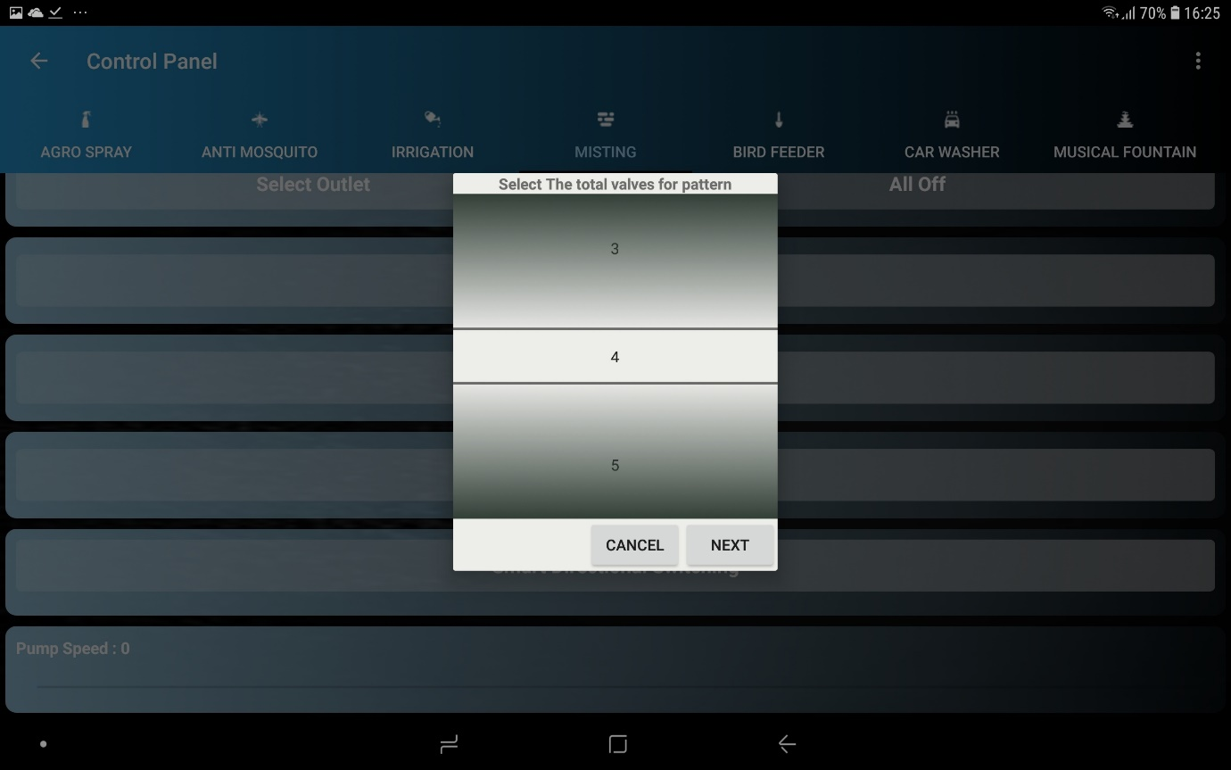

4. Then, a dialog box saying "Select the pattern" appears, the desired pattern is selected, (in this Case, “Counter Clock Wise" pattern is selected, means valves will turn on and off in a counter clockwise fashion) and then "NEXT" button is pressed.

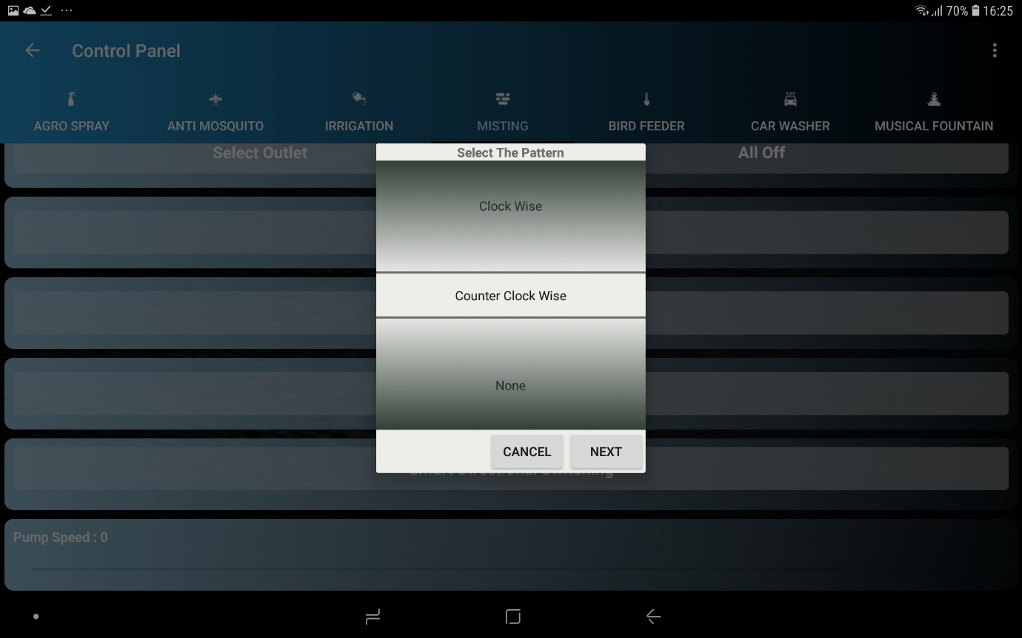

**Start the Music working**

1. " Start the Music" button is for singing fountain.

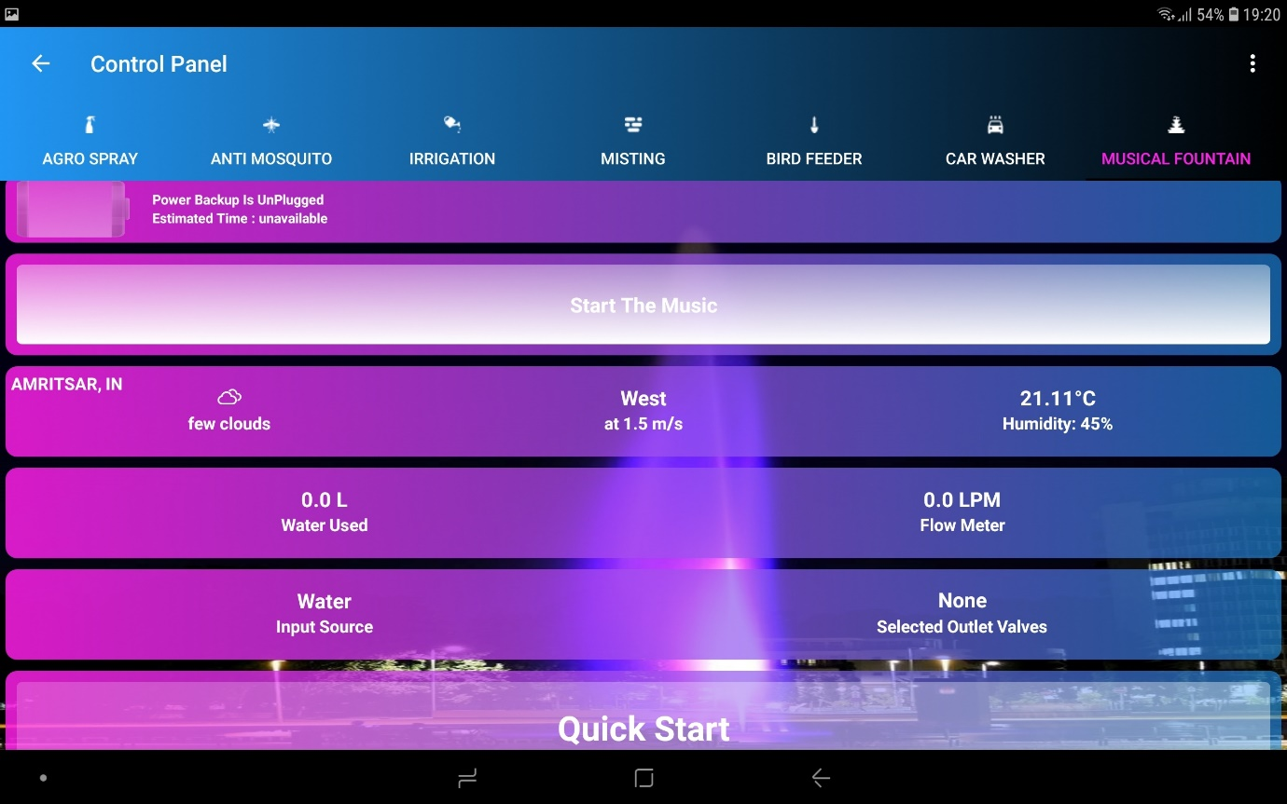

2. On pressing the button, a dialog box with audio visualizer appears and a continuous message is sent to the machine which is the value of the amplitude of the sounds in the surroundings, the machine in turn, switches on its valve or valves dedicated to the "Musical Fountain" function and the speed of the pump is mapped to the value of the message received by machine, and have, it gives a sense of singing/musical fountain. when “OK” button is pressed, musical fountain stops.

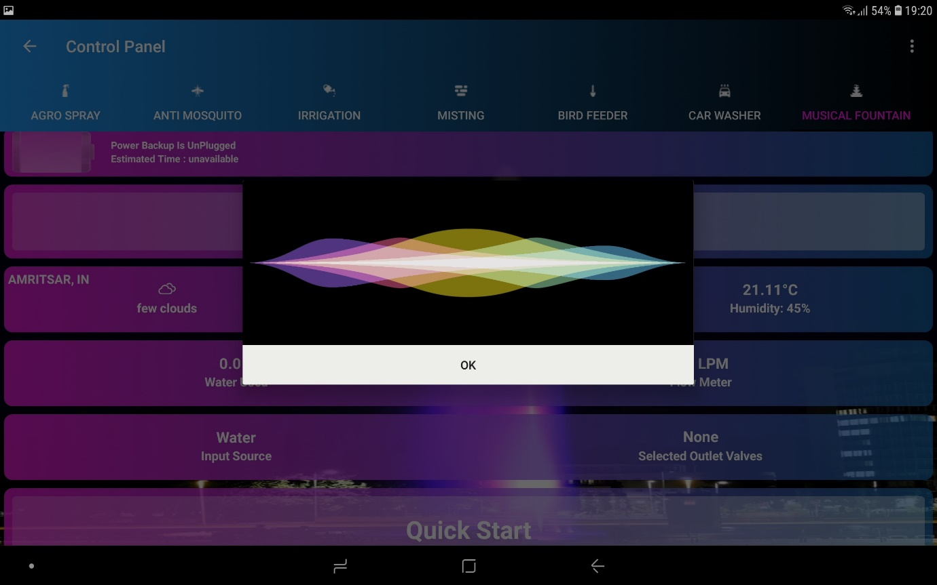

**Set the Schedule working**

1. Schedule for each function can be set individually.

2. To set the schedule for a function Let's Say for "MISTING" function in this example, "Set the schedule" button is pressed.

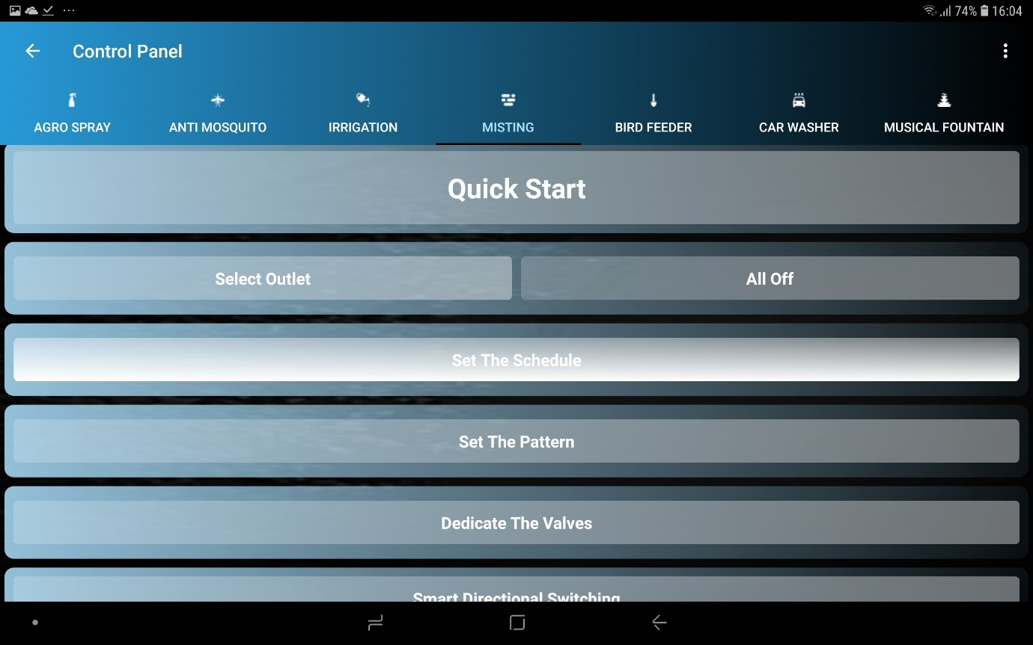

3. Then a dialog box appears saying "Select Valves for the purpose", the desired valves are selected, (second and third valve out of total eight valves in this case) and then, "NEXT" button is pressed.

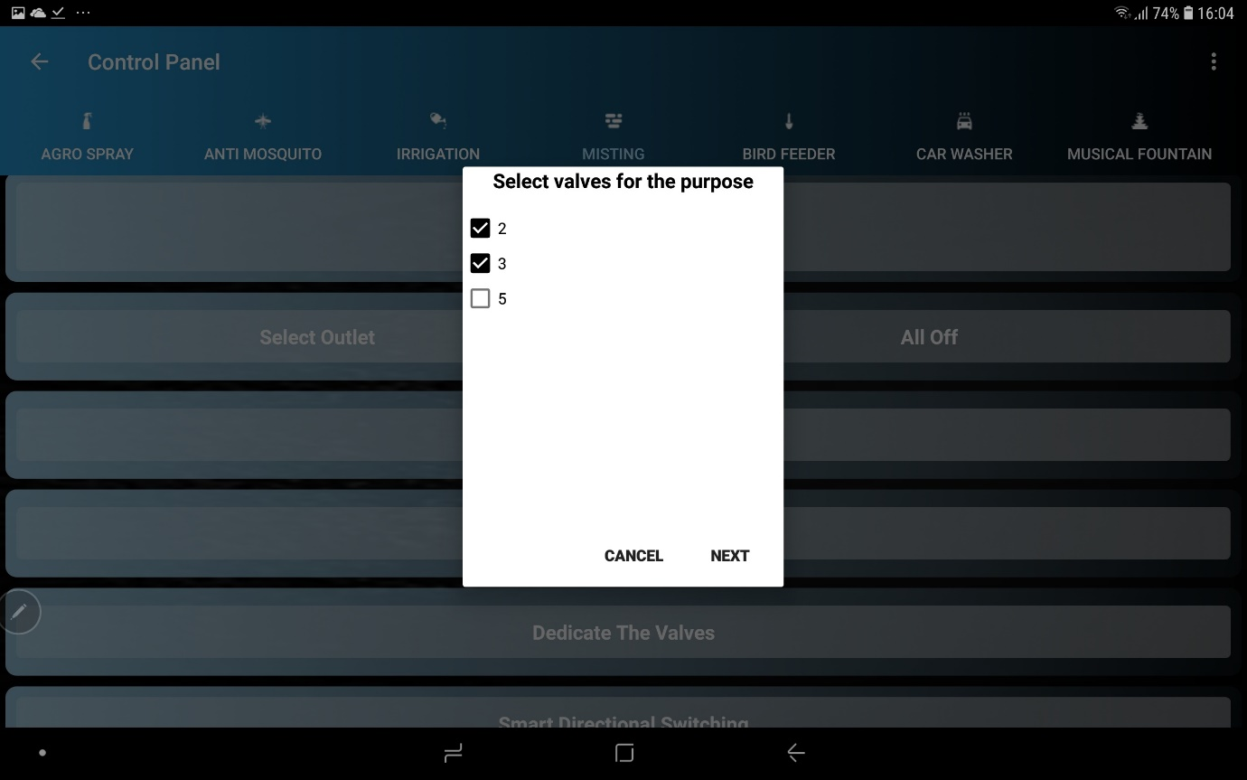

4. Then a dialog box appears to set the speed of the pump, with the help of seekbar, the desired speed is selected and "NEXT" button is pressed.

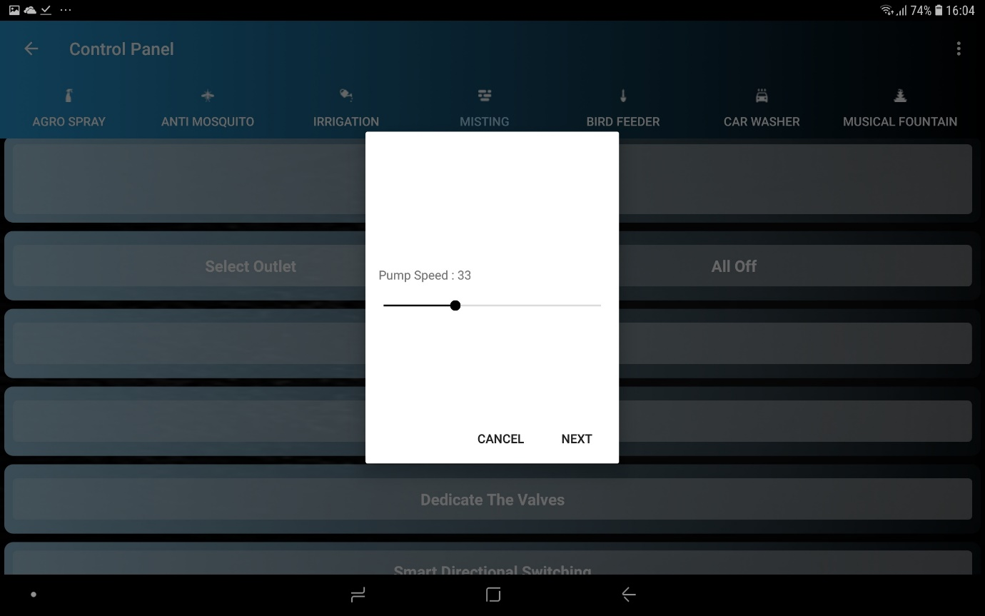

5. Then, a dialog box appears saying " Set the Frequency" the desired periodicity is selected and "NEXT" button is pressed.

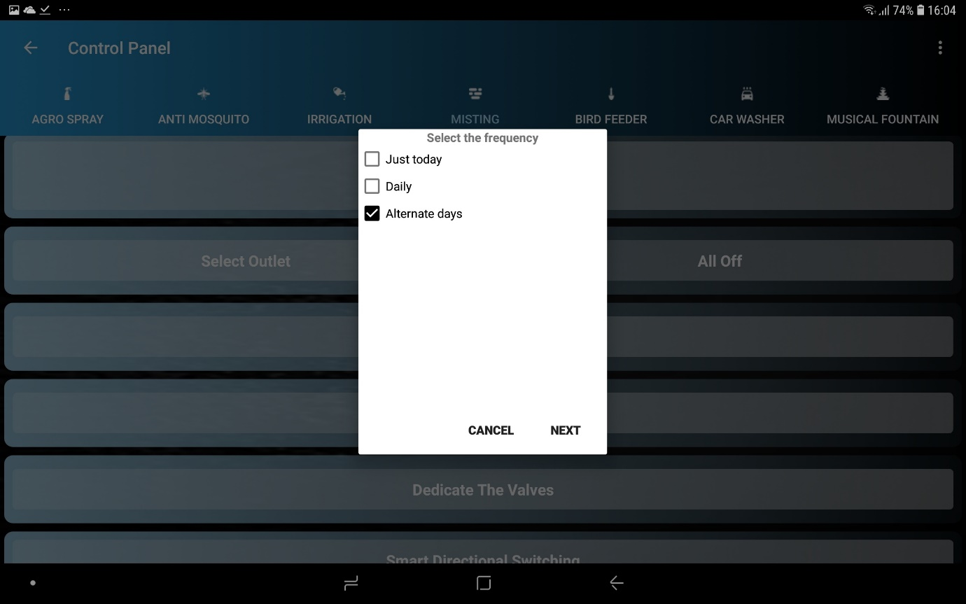

6. Then, a dialog box to pick the time of operation appears and the desired time is selected and then, "NEXT" button is pressed.

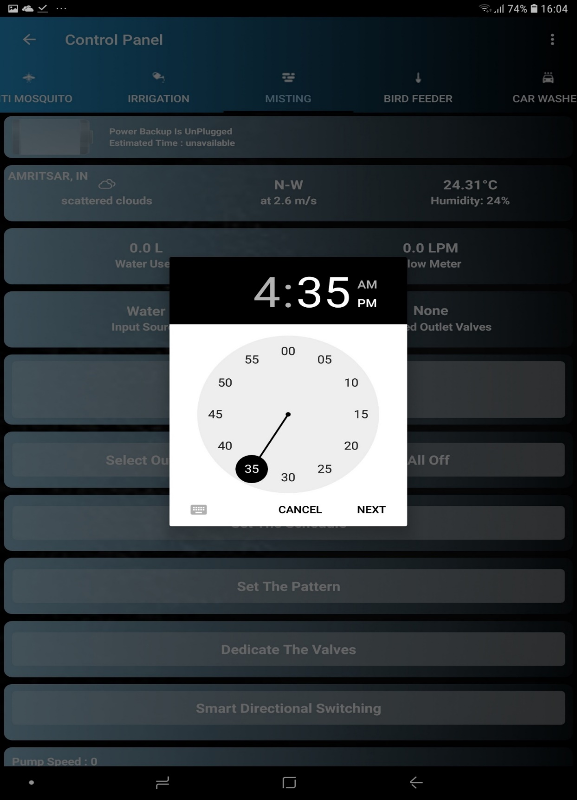

7. Then, a dialog box saying, " Set the duration (in minutes)" appears, the desired duration is selected and "FINISH" button is pressed.

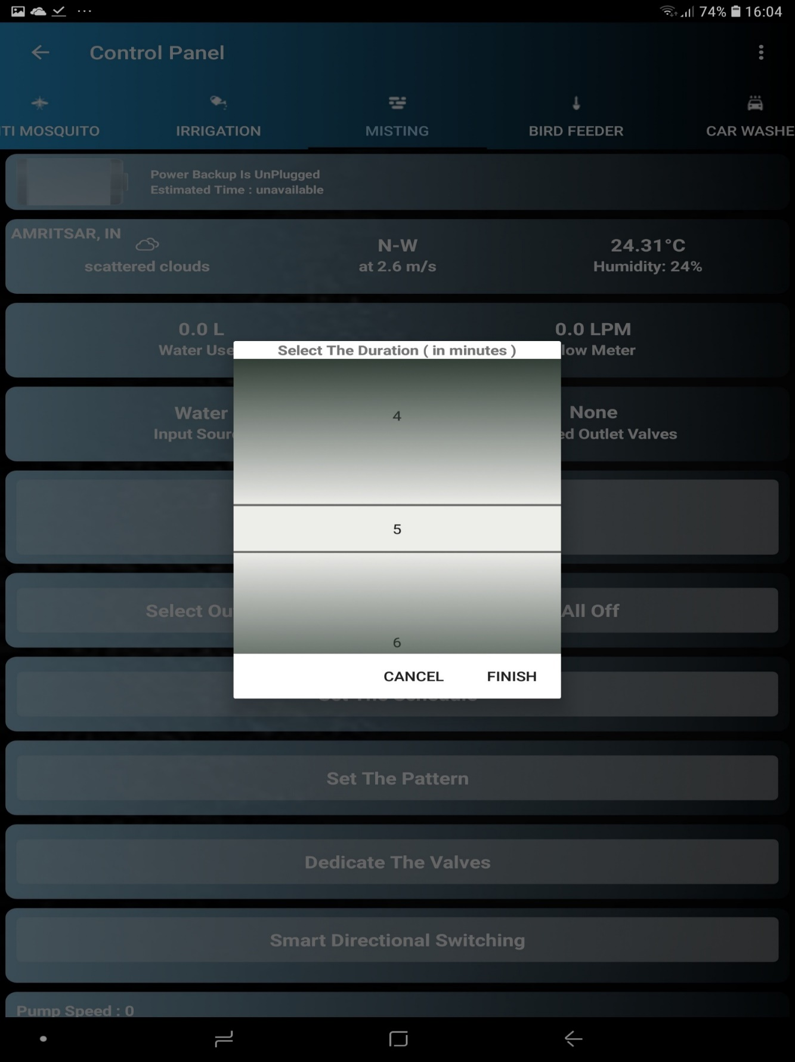

8. The result is that “Misting will happen at valves second and third at pump speed: 33 on every alternate day starting today at time 04:35 PM for 5 minutes duration”.

